**Pilot MRT: Checks of Implemented Trial Design**

Lauren Zimmermann, Jamie Yap, Ewa Czyz

This document provides information on the checks performed for assurance of implemented trial design for Aim 3, which is the micro-randomized trial (MRT) portion of the pilot study titled: *Developing text-based support for parents of adolescents after an emergency department visit*.

The source of the funding is the National Institute of Mental Health, R34-MH-124767 grant (PI: Ewa Czyz).

**Table of Contents:**

1. **Preface**
2. **Checks on Quality of Randomization**
   1. *Examining Balance among Control Covariates*
   2. *Examining Empirical Probabilities of Being Randomized to Parent-Focused Text*
3. **Checks of Missing Data**
   1. *Examining Missingness within Primary Proximal Outcome*
4. **References**

**I. Preface**

We wish to remind the reader that, as a pilot study, this initial development of the proposed just-in-time-adaptive-intervention to deliver support for parents of suicidal adolescents served as a learning opportunity for gathering information about challenges with respect to implementing the intended study design. This information is critical to inform and overcome such feasibility considerations in the design of a full scale MRT.

As detailed in the documentation file titled *1.Pilot MRT Master Documentation*, the analytic sample for this pilot MRT entailed 40 parents of suicidal adolescents that were micro-randomized twice per day for the 6-week or 42-day (84 decision points per participant) study. Note that, out of the original 41 participants in the MRT arm, one parent withdrew on Day 1 of the study and, as such, did not have a consecutive prior randomization assignment and subsequent proximal outcome measurement; this rendered 40 parents in the analytic sample for the pilot MRT. Likewise, the sample size referred to throughout this document of N=3,356 participant-decision points arises from having (39 parents x 84 decision points) + (1 parent who withdrew on day 40 x 80 decision points), across the MRT analytic sample of 40 parents.

Throughout the materials in this repository, we denote the intervention components of the adolescent-focused and parent-focused support mobile texts in italics as follows: *A-F text* and *P-F text*, respectively.

**II. Checks on Quality of Randomization**

*A. Examining Balance among Control Covariates*

Guided by the existing science, the following baseline variables were expected to be associated with both the proximal outcome of parent stress and with the augmented intervention component of parent-focused support text, and, as such, were considered as control covariates: teen sex (male/female), parent sex (male/female), teen multiple attempt status (yes/no), teen disposition at index ED visit (home/inpatient), baseline teen PHQ-9 (reflects adolescent depression severity), baseline parent PHQ-4 (reflects parent anxiety and depression), and baseline parent’s stress. We check whether balance was achieved with respect to the randomization assignment of augmenting with the *P-F text* vs. not augmenting with the *P-F text* for each control covariate, using Cohen’s d (where values close to 0 indicate similarity between groups) for binary covariates and an analogous standardized difference (where similarly values close to 0 indicate balance) for the continuous covariates.

**Table 2** and **Table 3** display the measure of difference in the baseline control covariates between the augment with *P-F* *text* vs. do not augment with *P-F text*.

Among binary control covariates, we observe that the randomizations were balanced between female and male adolescents, female and male parents, teen multiple attempters and non-multiple attempters, and teen home and inpatient dispositions, respectively (**Table 2**).

**Table 2**. Average balance for baseline binary covariates, across decision points (N=3,356)

|  |  |  |  |
| --- | --- | --- | --- |
| **Covariate (Group 1, Group 2)** | **Group 1**  **(# in Augment with *P-F Text*, Total # in Group)** | **Group 2**  **(# in Augment with *P-F Text,* Total # in Group)** | **Cohen’s d**  **(Std. Dev. Across Full Sample)** |
| Teen Sex (Male, Female) | 0.440 (n=481; N=1092) | 0.462 (n=1045; N=2264) | -0.042 (0.498) |
| Parent Sex (Male, Female) | 0.429 (n=144; N=336) | 0.458 (n=1382; N=3,020) | -0.058 (0.498) |
| Multiple Attempt (No, Yes) | 0.466 (n=1017; N=2184) | 0.434 (n=509; N=1172) | 0.063 (0.498) |
| Disposition at Index ED Visit (Home, Inpatient) | 0.464 (n=741; N=1596) | 0.446 (n=785; N=1760) | 0.037 (0.498) |

Among continuous control covariates, we use an approach developed by Luers and collaborators *(1)* to estimate standard effect sizes for each decision point, that being the fitted value from a LOESS curve. We opted to use this method because it is suitable for the mobile health data and continuous proximal outcomes at-hand. In turn, we similarly observe that the randomizations were balanced with respect to teen PHQ-9 (reflects adolescent depression severity), parent PHQ-4 (reflects parent anxiety and depression), and parent’s stress (**Table 3**); all as measured at baseline.

**Table 3**. Average balance for baseline continuous covariates, across decision points (N=3,356)

|  |  |  |
| --- | --- | --- |
| **Covariate** | **Mean Difference** | **Standardized Difference**  **(Std. Dev.)** |
| Teen PHQ-9 (Depression Severity) | -0.236 | -0.046 (5.120) |
| Parent PHQ-4 (Anxiety and Depression) | 0.012 | 0.003 (3.550) |
| Parent Stress | -0.314 | -0.057 (5.497) |

**Figure 4** shows the distributions of the continuous control covariates for those parents randomized to the parent-focused text and no parent-focused text, across all decision points in the study time period. The plots visually align with the results shown in **Table 3** above, in that the *P-F text* and no *P-F text* groups were similar with respect to the distributions of the continuous control covariates at baseline.

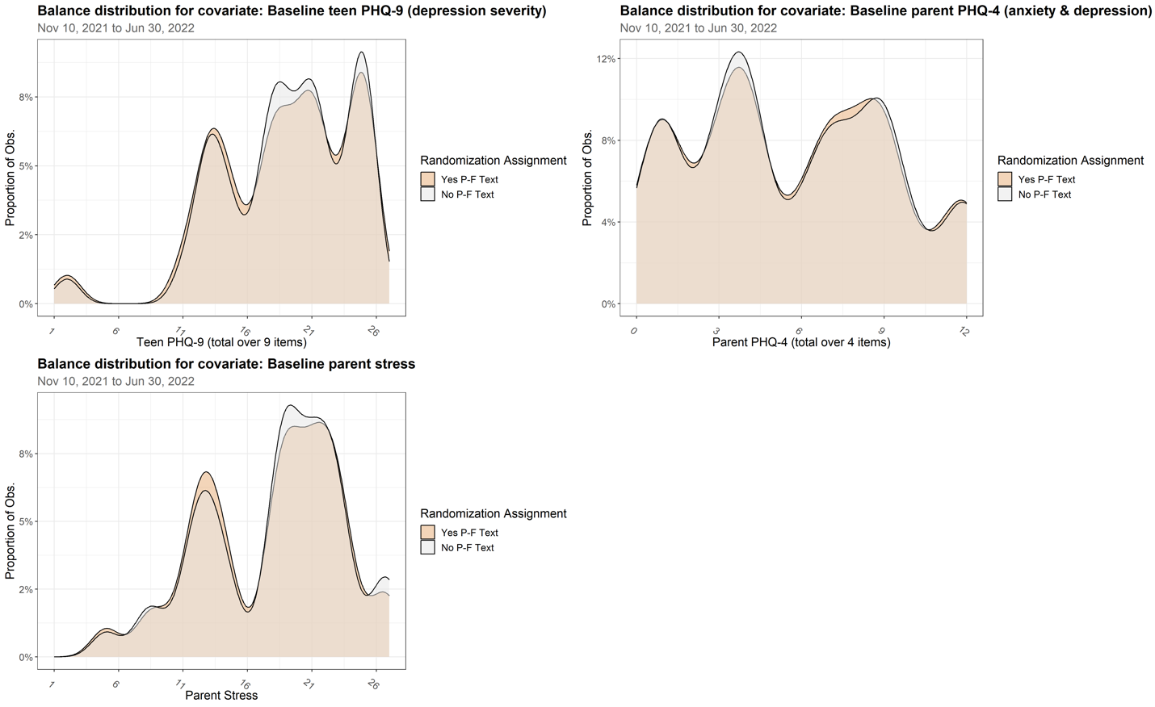**Figure 4**. Distributions of continuous control covariates, among participants being randomized to augment with *P-F text* versus do not augment with *P-F text*.

*B. Examining Empirical Probabilities of Being Randomized to Parent-Focused Text*

We performed the check of whether the empirical (or observed) randomization probability aligned with the intended (or expected) constant randomization probability of 0.5, or whether the confidence interval bounds contained the expected randomization probability. This check was to confirm that the element of the intended study design that the randomization probability was constant at 0.5 was reflected in the data. To perform this diagnostic, we first plotted the expected randomization probability against the observed randomization probability marginal over time and marginal over morning and evening time windows.

**Figure 5** displays the empirical marginal probability of being randomized to the *P-F text*, overall, as well as for the morning and evening. The observed marginal randomization probability was 45.5% (95% confidence interval [CI]: 43.8, 47.2); the CI did not contain the expected randomization probability of 50%, as designated in the trial design. Similar results were rendered for the morning and evening randomizations.

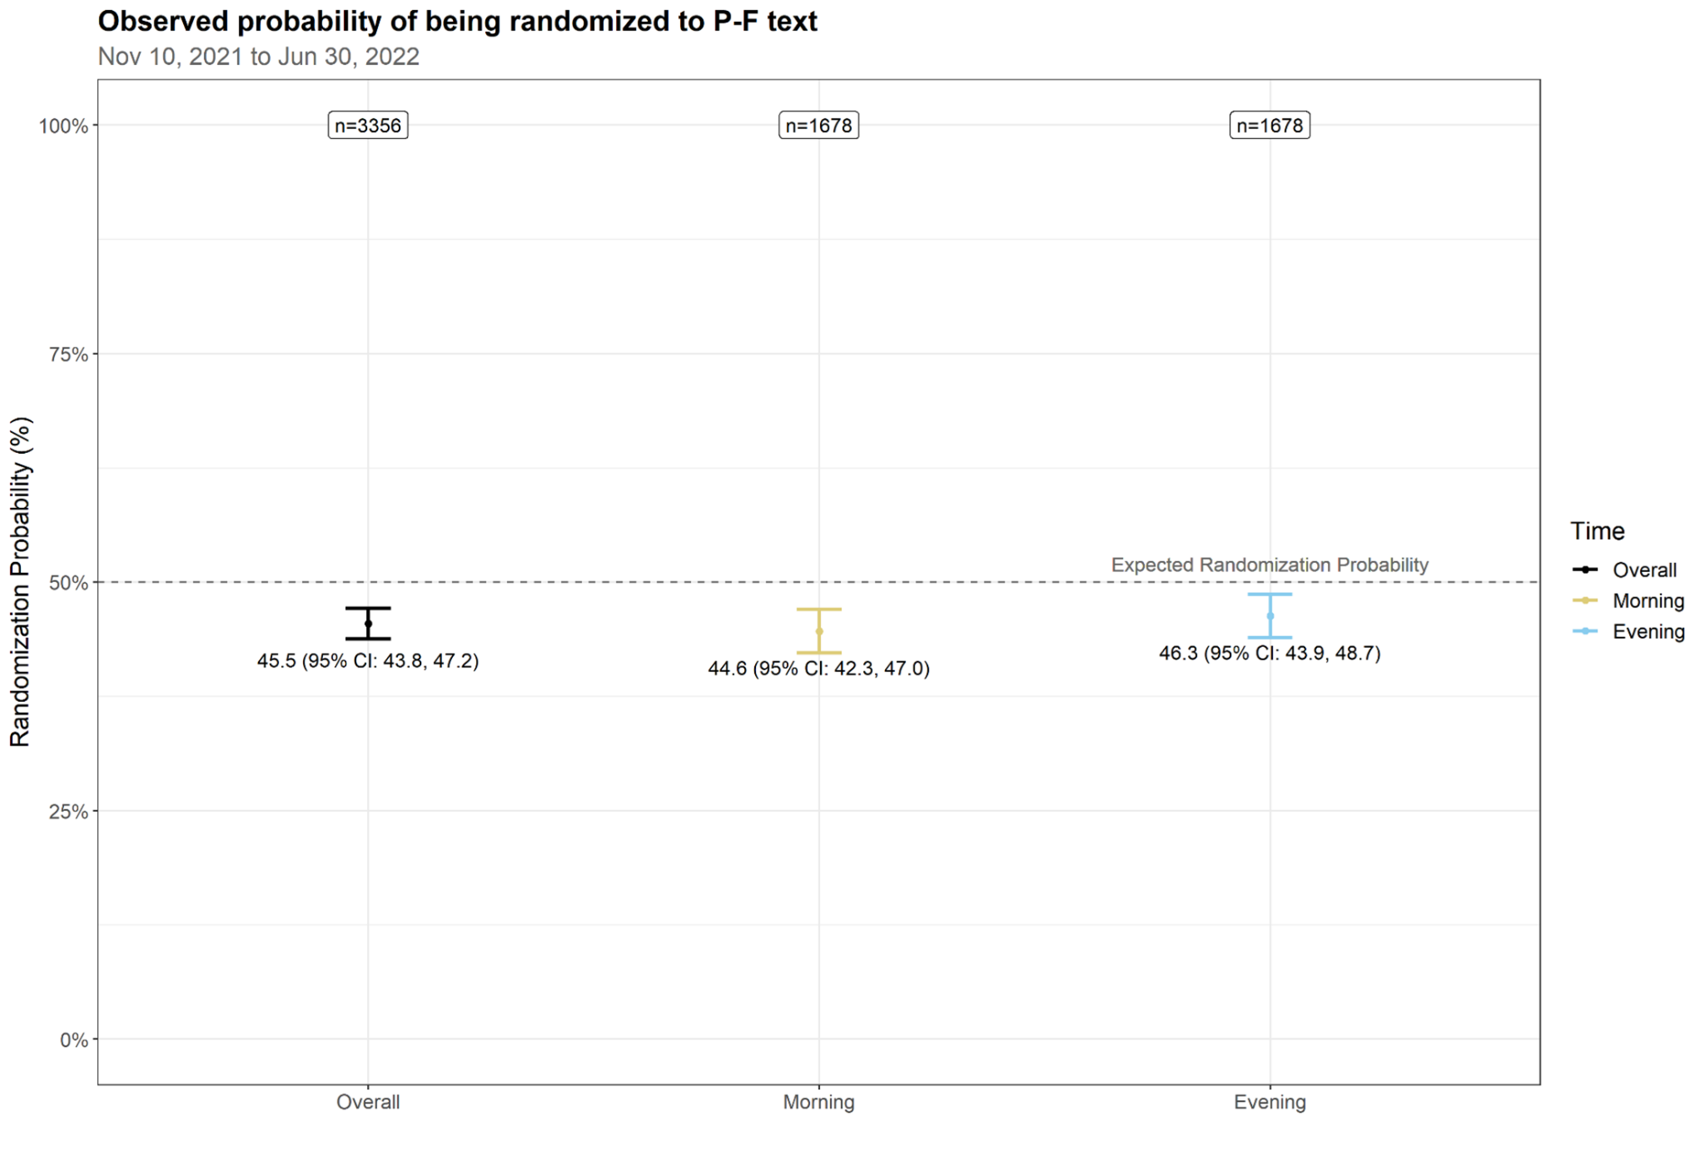**Figure 5**. Observed vs. expected probability of being randomized to augment with *P-F text*, marginal over time (left), as well as separately for morning (middle) and evening (right).

Next, we examined the randomization probabilities at the day-, person- and decision point-level, with corresponding 95% confidence intervals (CI). We let denote the randomization probability at decision point t and represent the observed value at decision point t. The confidence intervals were computed as .

**Figure 6** shows the observed probability of parents being randomized to augment (vs. not augment) with the *P-F text* at various levels of aggregation. On the 28th day in the study, the randomization probability considerably deviated from the intended randomization probability of 50% in that it was 20% and 10% for the morning and evening decision points, respectively.

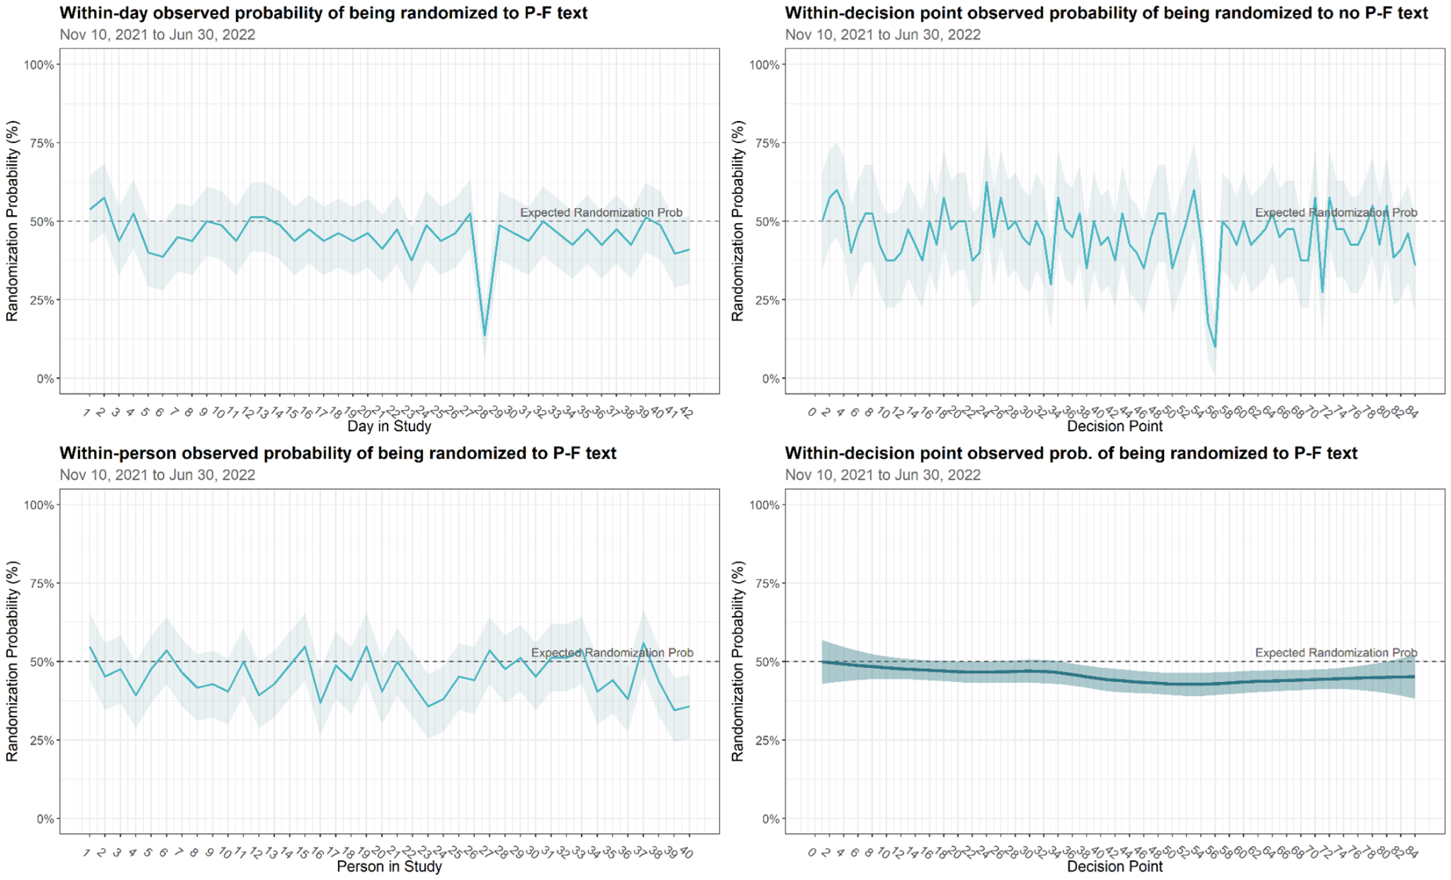

**Figure 6**. Observed vs. expected probability of being randomized to augment (vs. not augment) with *P-text* within-day (top left), within-person (bottom left), within-decision point (top right), and a smoothed version, using a non-parametric locally estimated scatterplot smoothing (LOESS) with 95% CI band (bottom right).

We removed day 28, where there was a considerable decrease in the randomization probability from = 53% on day 27 to = 20% on day 28 for decision point 55 and 10% for decision point 56, in order to see whether day 28 may have been a glitch in the software that was driving the marginal randomization probability to not cross 50%. The observed marginal randomization probability changed from 45.5% (95% confidence interval [CI]: 43.8, 47.2) to 46.2% (95% CI: 44.5, 48.0) (see **Figure 7** below). Hence, the overall estimate and corresponding confidence intervals were closer to 50%, when restricting to without day 28. In the proceeding documentation file *3.Pilot MRT Main and Sensitivity Analyses*, we will detail an analysis plan that incorporates examining whether the findings were sensitive to this observed deviation in the randomization probability.

**Figure 7**. When restricting to without day 28, observed vs. expected probability of being randomized to augment with *P-F text*, marginal over time (left), as well as separately for morning (middle) and evening (right). For overall (left) when restricting to without day 28, this reflects 3,276 participant-decision points = 3,356 - (40 participant-decision points in the morning on day 28) - (40 participant-decision points in the evening on day 28).

**III. Checks of Missing Data**

*A. Examining Missingness within Primary Proximal Outcome*

We examined the extent of missing data in the primary proximal outcome of parent stress that measured via twice-daily ecological momentary assessments (EMA). We also examined missingness in the secondary proximal outcome of parent affect (positive/negative), and similar results were rendered. In this pilot study, missing data in the proximal outcome was primarily due to EMA adherence (parent engagement in EMA completion) and secondarily due to study withdrawal (1 parent in the MRT arm withdrew toward the end of the study on day 40, out of 42 total days).

**Figure 8** displays the pattern of missingness in parent stress, and has the following structure:

* The rows represent participants (N=40 parents) and the columns represent decision points or observations (e.g., “Obs 1” denotes observation 1).
* Black shading denotes a missing value in the proximal outcome of parent stress and grey denotes a populated (or "complete") value, as observed in the EMA data.
* The percentages in the parentheses (at the top of the plot) denote the percent of missing values for that decision point. For example, for the first column "Obs 1 (15%)", we observe that 15% of parents did not respond to the questionnaire item DS-9 for the proximal outcome of parent stress, corresponding to decision point 1.
* The bottom percentages are the total missingness across all data points for the proximal parent stress: i.e., across all parents and decision points in the MRT sample, missingness was 32.4% in the proximal outcome of parent stress.

The percent missingness was generally increasing over the study time period, which aligns with existing literature that participant engagement in ecological momentary assessments (or EMA adherence) often decreases over time *(2)*.

In the next documentation file *3.Pilot MRT Main and Sensitivity Analyses*, we will detail an analysis plan that incorporates two sensitivity analyses with respect to accounting for missing data in the setting of this pilot study.

**Figure 8**. Pattern of missingness for proximal parent stress.

1. **References**
2. Luers, B., Klasnja, P., & Murphy, S. (2019). Standardized effect sizes for preventive mobile health interventions in micro-randomized trials. *Prevention Science*, *20*, 100-109.
3. Perski, O., Keller, J., Kale, D., Asare, B. Y. A., Schneider, V., Powell, D., ... & Kwasnicka, D. (2022). Understanding health behaviours in context: A systematic review and meta-analysis of Ecological Momentary Assessment studies of five key health behaviours. *Health Psychology Review*, *16*(4), 576-601.